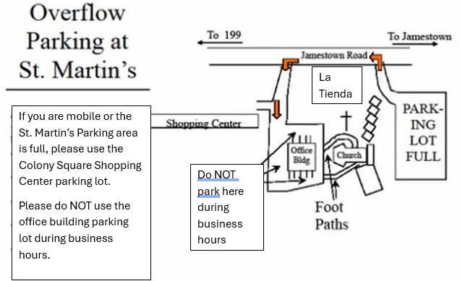
We will be holding services at St. Martin’s Episcopal Church (SME) located at 1333 Jamestown Road. The driveway for SME is next to La Tienda (not the Colony Square driveway).
The St. Martin’s parking area includes only 59 regular parking spaces and 6 handicapped spaces. If those in your car are able to walk a short distance (including some stairs), we recommend that you use the overflow parking.
Please use the Colony Square Shopping Center for overflow parking. If you can deal with stairs, you can use the woodland path and stairs below La Tienda. Otherwise walk along Jamestown Road.
Please do not park in the La Tienda lot as it may be open for business during our services.

